

**SIMATS SCHOOL OF ENGINEERING**

**SAVEETHA INSTITUTE OF MEDICAL AND TECHNICAL SCIENCES**

**CHENNAI-602105**

**BLOOD BANK MANAGEMENT SYSTEM**

**A CAPSTONE PROJECT REPORT**

*Submitted in the partial fulfillment for the award of the degree of*

**BACHELOR OF ENGINEERING**

**IN**

**INFORMATION TECHNOLOGY**

**Submitted by**

**P. Mourya[ 192211771 ]**

**P.Sai Sujith Reddy[ 192211473 ]**

**P.Vijay Kumar[192211385]**

**K.Kishore[192211912]**

**Under the Supervision of**

**Dr. K.Rajagopal**

**SEPTEMBER 2024**

**DECLARATION**

We, **P.Mourya, P.Sai Sujith Reddy, P.Vijay Kumar, K.Kishore** students of **Bachelor of Engineering in** Department of Computer Science and Engineering, Saveetha Institute of Medical and Technical Sciences, Saveetha University, Chennai, hereby declare that the work presented in this Capstone Project Work entitled **Blood Bank Management System** is the outcome of our own bonafide work and is correct to the best of our knowledge and this work has been undertaken taking care of Engineering Ethics.

( P. Mourya 192211771 )

( P.Sai Sujith Reddy 192211473 )

(P.Vijay Kumar 192211385)

(K.Kishore 192211912)

Date: 21-10-2024

Place: Chennai

**CERTIFICATE**

This is to certify that the project entitled **“Blood Bank Management System”** submitted by **P. Mourya, P.Sai Sujith Reddy, P.Vijay Kumar, K.Kishore** has been carried out under my supervision. The project has been submitted as per the requirements in the current semester of B.E CSE.

Teacher-in-charge

Dr. K. Rajagopal

**Table of Contents**

|  |  |
| --- | --- |
| **S.NO** | **TOPICS** |
| 1 | **Abstract** |
| 2 | **Introduction** |
| 3 | **Project Description** |
| 4 | **Problem Description** |
| 5 | **Tool Description** |
| 6 | **Operations** |
| 7 | **Approach / Module Description / Functionalities** |
| 8 | **Implementation** |
| 9 | **Output** |
| 10 | **Conclsion** |
| 11 | **References** |

**Abstract**

The Blood Management System is a dynamic website aimed at streamlining the process of blood donation, requests, and management of blood inventory in healthcare institutions. This project emphasizes creating an efficient platform that connects donors, hospitals, and blood banks while ensuring secure and seamless operations. The system includes a user-friendly interface for registration, real-time inventory management, and a secure login system for authorized users.

**Introduction**

Blood donation is a critical healthcare service that saves millions of lives. However, managing blood donations and ensuring timely availability has been a challenge for many healthcare systems. The Blood Management System addresses these challenges by providing a centralized and dynamic platform to manage blood requests, donations, and stock in real-time. This system ensures that hospitals and blood banks can easily track blood availability and meet urgent demands efficiently.

**Project Description**

The Blood Management System is designed to provide a dynamic and responsive interface for donors, healthcare institutions, and blood banks. It allows users to register, log in, and manage their profiles. Hospitals can check the availability of specific blood groups and raise requests, while donors can keep track of their donation history and eligibility for the next donation.

**About project**

The project focuses on building a web application that integrates features such as user registration, secure login, real-time blood inventory, and request management. The aim is to ensure that blood donations are efficiently managed, and urgent requests are fulfilled by matching them with available blood stocks across different locations.

**Problem Description**

One of the primary problems in the current blood donation ecosystem is the lack of a centralized system for managing blood availability. Often, hospitals face shortages due to inefficient communication between blood banks and donors. This project solves the problem by creating a web-based system that maintains real-time blood inventory, facilitates blood requests, and manages donor information securely.

**Program to build a simple Software for Blood Management System**

**Tool Description**

* Programming Language: HTML, CSS, JavaScript, PHP.
* Database: MySQL for storing user information, blood requests, and donation history.
* Server: Apache (using XAMPP).
* Other Tools: Bootstrap for responsive design.

**User Interface**

The user interface includes a clean and responsive layout. The home page displays information about blood donation, and the login page allows registered users to access their account. There is a dashboard for both donors and hospitals to view blood availability and manage requests.

**Features**

* User Registration: Allows new users to register as donors or hospitals.
* Login: Secure access for registered users using email and password.
* Blood Inventory Management: Tracks the availability of different blood types.
* Request Management: Hospitals can request blood, and donors can view donation opportunities.
* Notifications: Alerts users when specific blood types are in demand.

**Operations**

The system includes various operations for both donors and hospitals:

* Donors can update their profile, view donation history, and register for new donations.
* Hospitals can view blood availability and request specific blood types when needed.

**Approach / Module Description / Functionalities**

The Blood Management System is designed with modularity in mind. Every operation is handled by a separate function, allowing ease of maintenance and future enhancements. Core modules include:

1. User Registration Module
2. Login Authentication Module
3. Blood Inventory Management Module
4. Request Management Module
5. Notification Module

All these functions work together to create a comprehensive software solution that efficiently manages the blood donation and request process.

**Implementation**

The system is implemented using front-end technologies (HTML, CSS, JavaScript) for the interface and PHP for server-side operations. The MySQL database stores all the relevant data, including user details, blood inventories, and requests. AJAX is used to fetch real-time data without refreshing the page.

**Output**

The final output of the project is a fully functional web application. The following screenshots demonstrate the core functionalities:

* User Registration Page: A clean form for new users to register.
* Login Page: Secure login system for donors and hospitals.
* Dashboard: Displays real-time blood inventory and donation history.
* Request Form: Hospitals can submit blood requests through an easy-to-use form.

**Pseudocode:**

<!DOCTYPE html>

<html>

  <head>

    <meta charset="UTF - 8">

    <meta name="viewport" content="width=devic-width" initial-scale="1.0">

    <title>Home page</title>

  </head>

  <style>

    body{

      margin:0px;

      padding:0px;

    }

   .navbar{

    margin:auto;

    padding:0px;

    display:flex;

    justify-content:space-between;

   }

    .navbar ul{

      list-style-type:none;

      width:100%;

      background-color:rgb(121, 118, 118);

      padding:0px;

      margin:0px;

      overflow:hidden;

    }

    .navbar a{

      text-decoration:none;

      color:white;

      display:block;

      text-align:center;

      padding:15px;

    }

    .navbar a:hover{

      background-color:rgb(32, 16, 16);

    }

    .navbar li{

      float:right;

    }

   .donorinfo{

    display:flex;

    justify-content:center;

    align-items:center;

    flex-wrap:wrap;

   }

   .donorinfo img{

    width:400px;

    height:300px;

    margin:100px;

    padding:10px;

    border-radius:13px;

    box-shadow:0px 0px 10px black;

    cursor:pointer;

    transition:0.15s;

   }

   .donorinfo img:hover{

    filter:brightness(1);

    transform:scale(1.03);

   }

    .de h3{

      margin-left:355px;

      margin-top:-70px;

      font-size:25px;

    }

    .he h3{

      margin-left:985px;

      margin-top:-60px;

      font-size:25px;

    }

    .donorinfos{

    display:flex;

    justify-content:center;

    align-items:center;

    flex-wrap:wrap;

   }

   .donorinfos img{

    width:400px;

    height:300px;

    margin:100px;

    padding:3px;

    border-radius:13px;

    box-shadow:0px 0px 10px black;

    cursor:pointer;

    transition:0.15s;

   }

   .donorinfos img:hover{

    filter:brightness(1);

    transform:scale(1.03);

   }

    .des h3{

      margin-left:340px;

      margin-top:-70px;

      font-size:25px;

    }

    .hes h3{

      margin-left:935px;

      margin-top:-60px;

      font-size:25px;

    }

  </style>

  <body>

    <nav class="navbar">

      <ul>

        <li><a href="logingit.html">Logout</a></li>

        <li><a href="aboutus.html">About Us</a></li>

        <li><a href="searchbloodbankgit.html">Blood banks</a></li>

        <li><a href="request.html">Request</a></li>

        <li><a href="">Home</a></li>

      </ul>

    </nav>

    <div class="main">

    <img src="blood6.jpg" width="100%">

  </div>

    <div class="donorinfo">

      <a href="postdongit.html"><img src="pdi.jpg"  ></a>

      <a href="mydongit.html"><img src="mydon.jpg" ></a>

    </div>

    <div class="de">

      <h3>Post Donor Info</h3>

    </div>

    <div class="he">

      <h3>My Donor Info</h3>

    </div>

    <div class="donorinfos">

      <a href="searchdongit.html"><img src="sd.jpg"></a>

      <a href="searchbloodbankgit.html"><img src="bloodbank.jpg" ></a>

    </div>

    <div class="des">

      <h3>Search donar details</h3>

    </div>

    <div class="hes">

      <h3>Search Blood bank details</h3>

    </div>

  </body>

</html>

**Result**

**Home Page:**

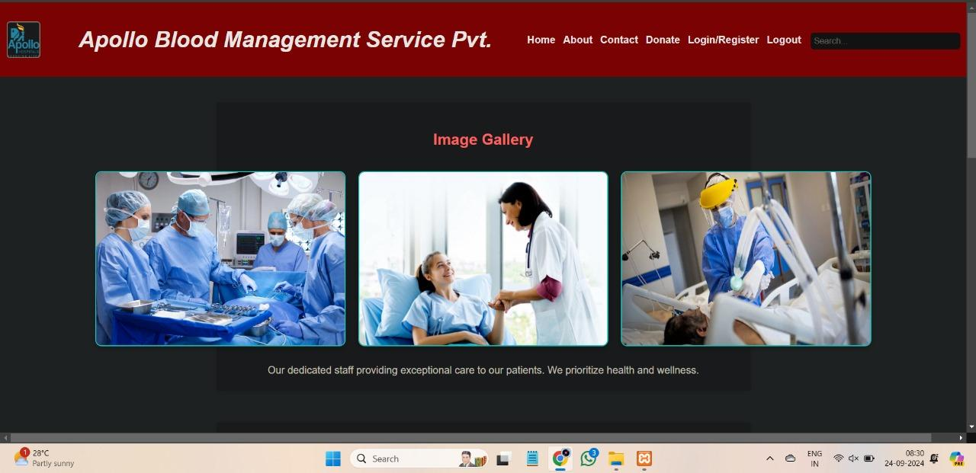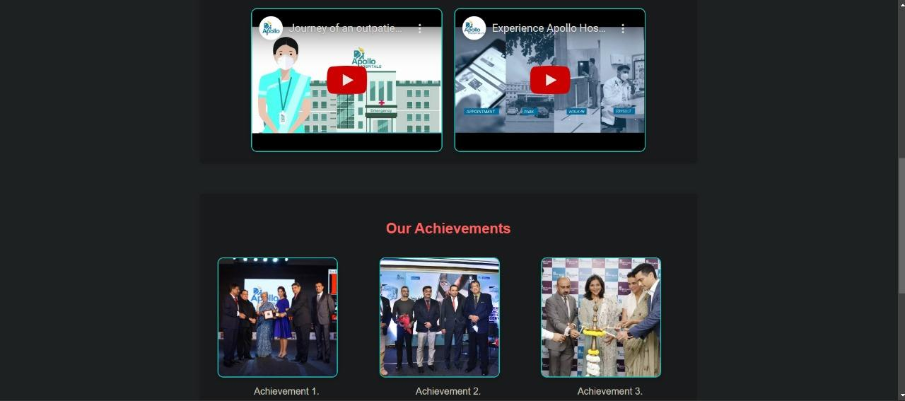

**About Page:**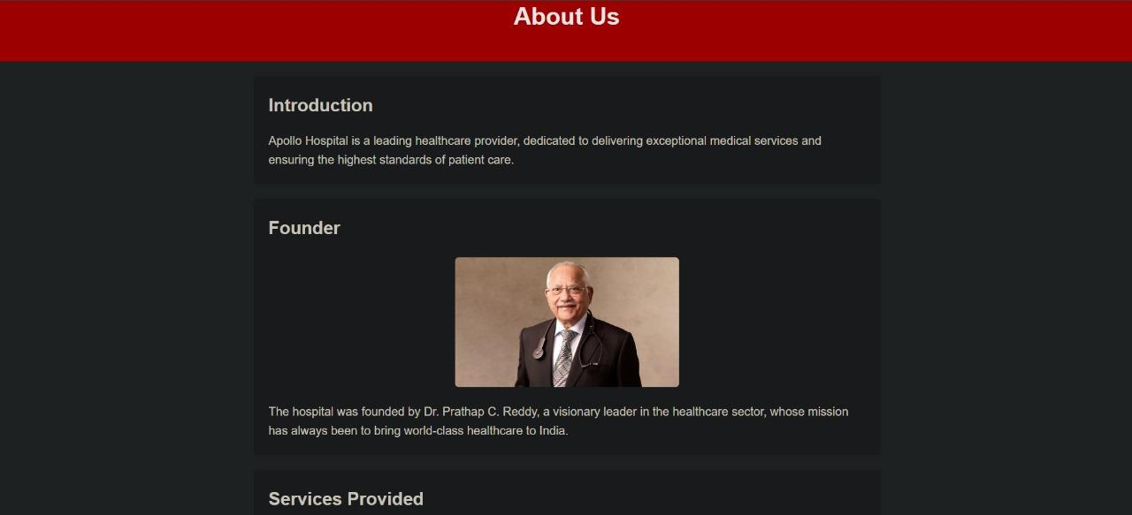

**Contact Us Page: 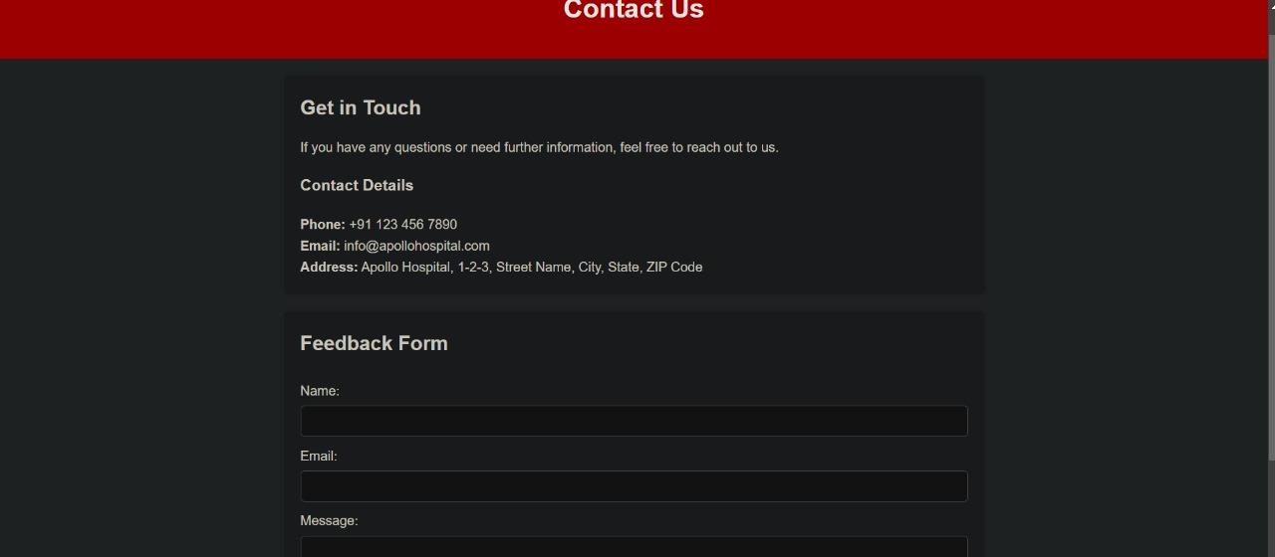Donate Page:**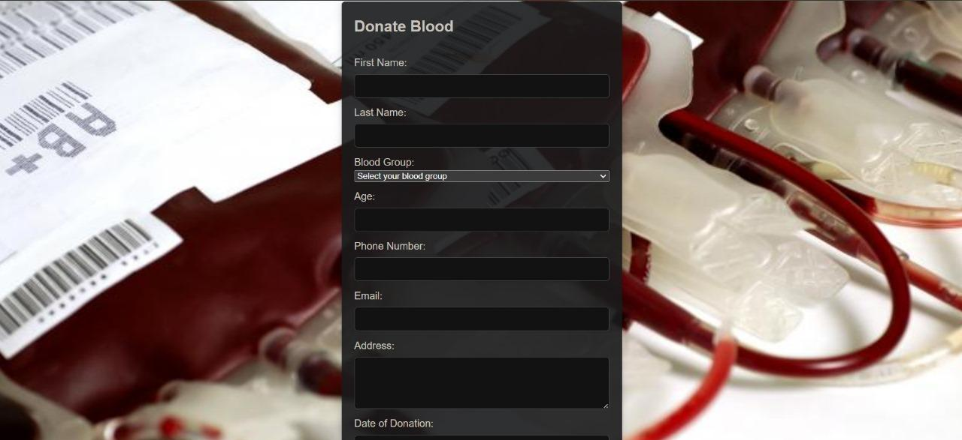

**Login / Register Options:** 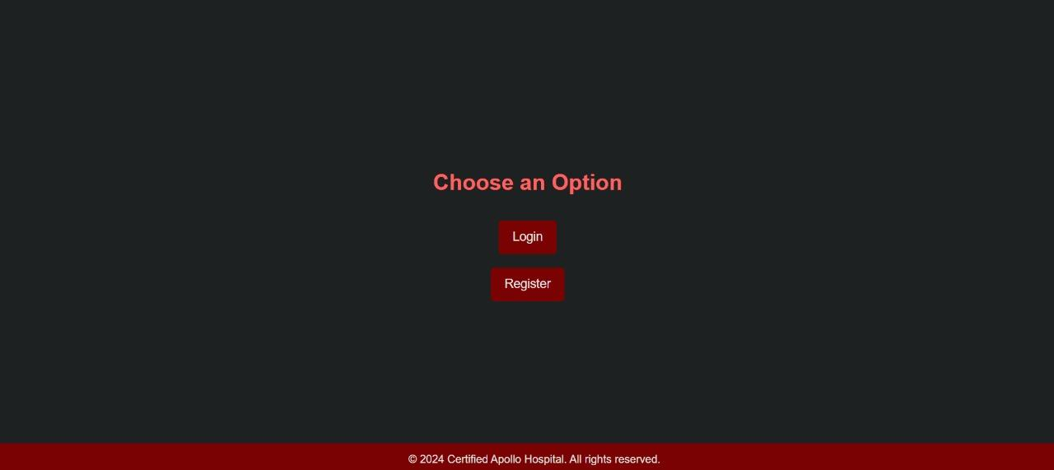

**User / Admin Login: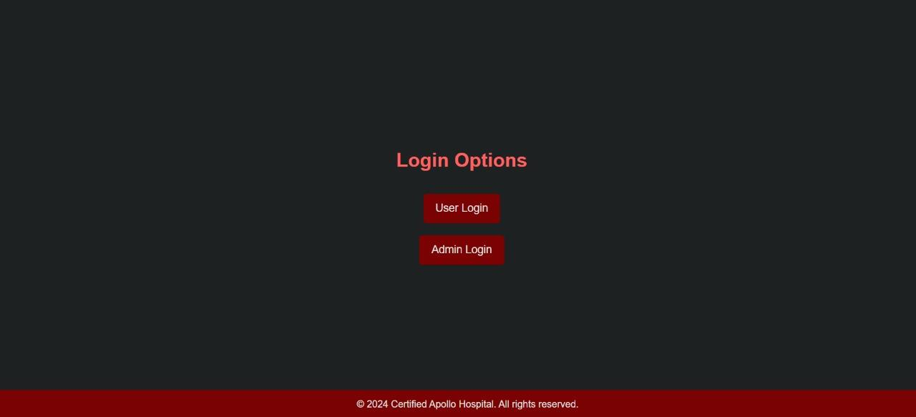Register Account:** 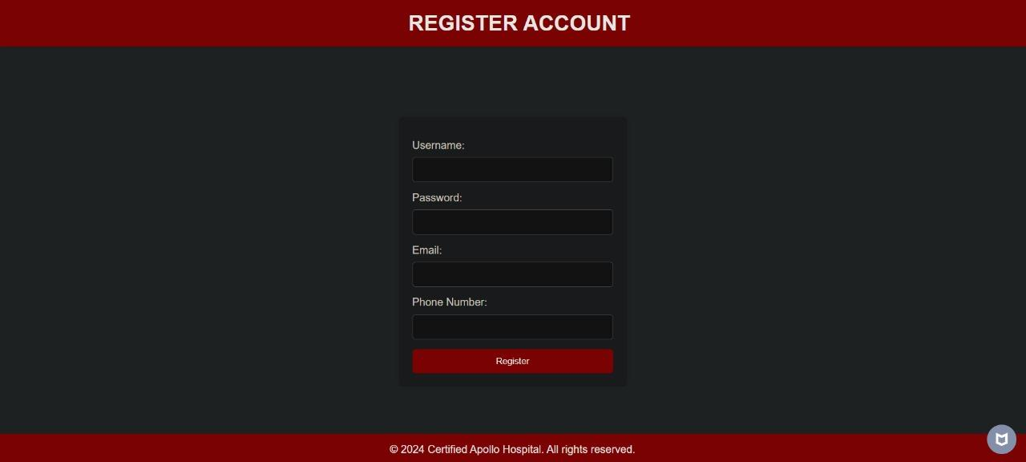

**User / Admin Login Page: 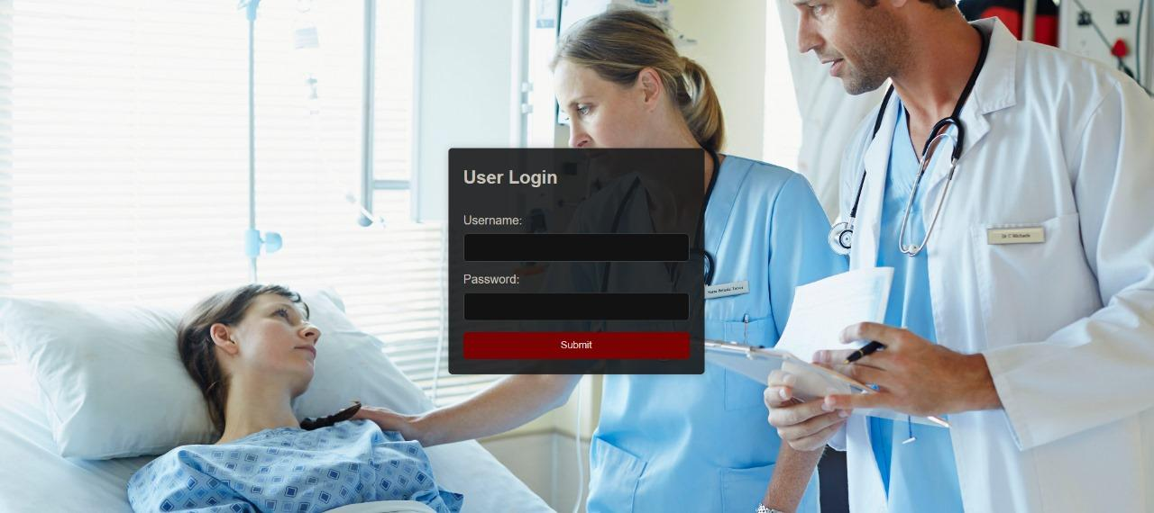Admin Home Page:** 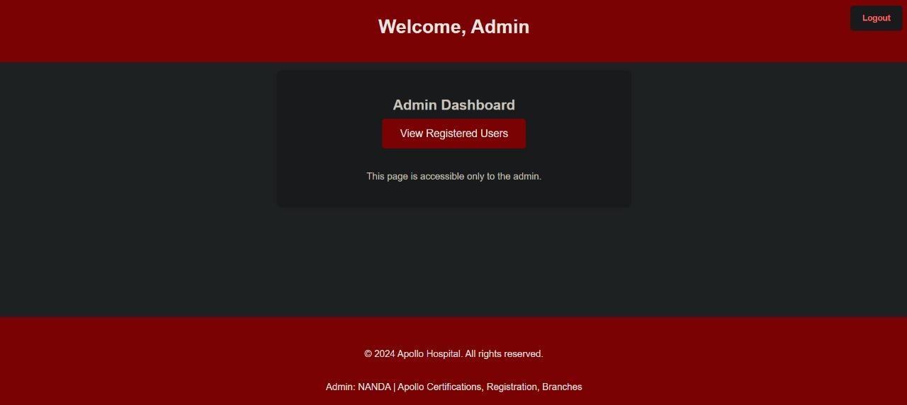

**Registered Users and Donations:**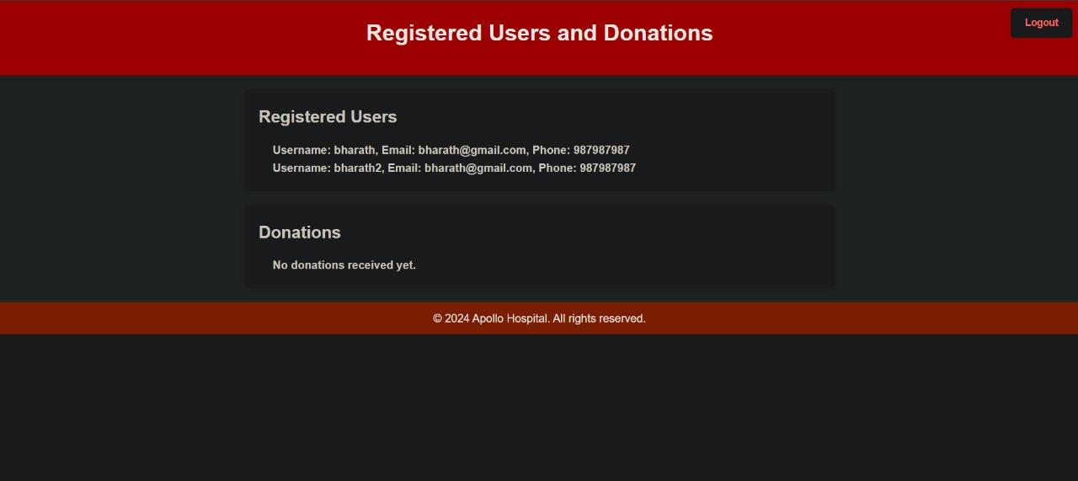

**Conclusion**

The Blood Bank Management System successfully addresses the problem of inefficient blood donation management by providing a centralized platform for both donors and healthcare institutions. In the future, this system can be enhanced by integrating features like mobile notifications, automated blood drive scheduling, and a machine-learning-based prediction system for blood demand.

**References**

1. W3Schools. "HTML Tutorial."
2. MDN Web Docs. "JavaScript Guide."
3. PHP Documentation. "Working with MySQL Databases."
4. Bootstrap. "Building Responsive Web Pages."